

Computer science

Name: Afwerki ghirmay

Student ID:3918095

Lecturer: Mike Child

# Object Oriented programming

Table of Contents

Object Oriented programming 1

Introduction 4

Some benefits of OOP are the following 4

What is class? 4

What is object? 4

The relationship between objects 4

Inheritance 5

Polymorphism 5

1. compile time polymorphism 6

Overloading polymorphism 6

Overriding polymorphism 7

2. Runtime overriding polymorphism 8

Abstraction 8

Encapsulation 10

The given scenario 12

What is UML diagram 12

Class diagram 12

1. Uploading images using buttons or similar mechanism. 13

2. UI resizing to fit the image 14

3. Adding or removing any number of annotation 15

4. Saving the annotated image 16

Conclusion 17

Bibliography 18

Pictures

Association between classes 1 3

OOP programming techniques2 3

Polymorphism 3 4

UML Diagram of the system 4 11

Image uploading 5 11

UI resizing to fit the image 6 13

UI resizing to fit another image 7 13

Adding and removing annotation 8 14

The annotated image saving 9 14

# Introduction

Object oriented programming is a programming style that follow certain rules and methods to create an object that can hold both the data and methods.

## Some benefits of OOP are the following

* OOP is faster and easier way of programming
* OOP offers a clear structure for programming
* OOP prevent from repeating the code, easier way of modifying and debugging.
* OOP can allow to reuse the application with less code and shorter development time.

Overall there are two main aspects of OOP. This are classes and objects.

### What is class?

class is a collection of object. in other words class is a blueprint of object.

### What is object?

Object is an interface of the class. Any entity that have state and behaviour is known as an object. object have a particular space in the memory. Objects can communicate each other without knowing each other’s data (Javatpoint, 2016).

### The relationship between objects

The relationship between two classes that can be established through there object is called association. The association between classes can be one to one, one to many, and many to many.

in OOP object can communicate each other to inherit the functions and services that are available by the other object. In associations there are two forms which are aggregation and composition (Help, 2018).

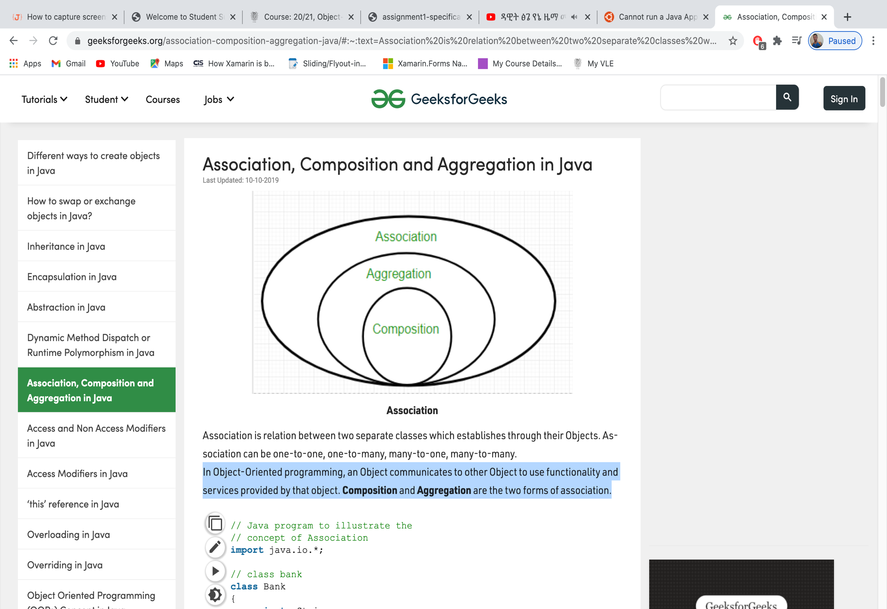

Association between classes

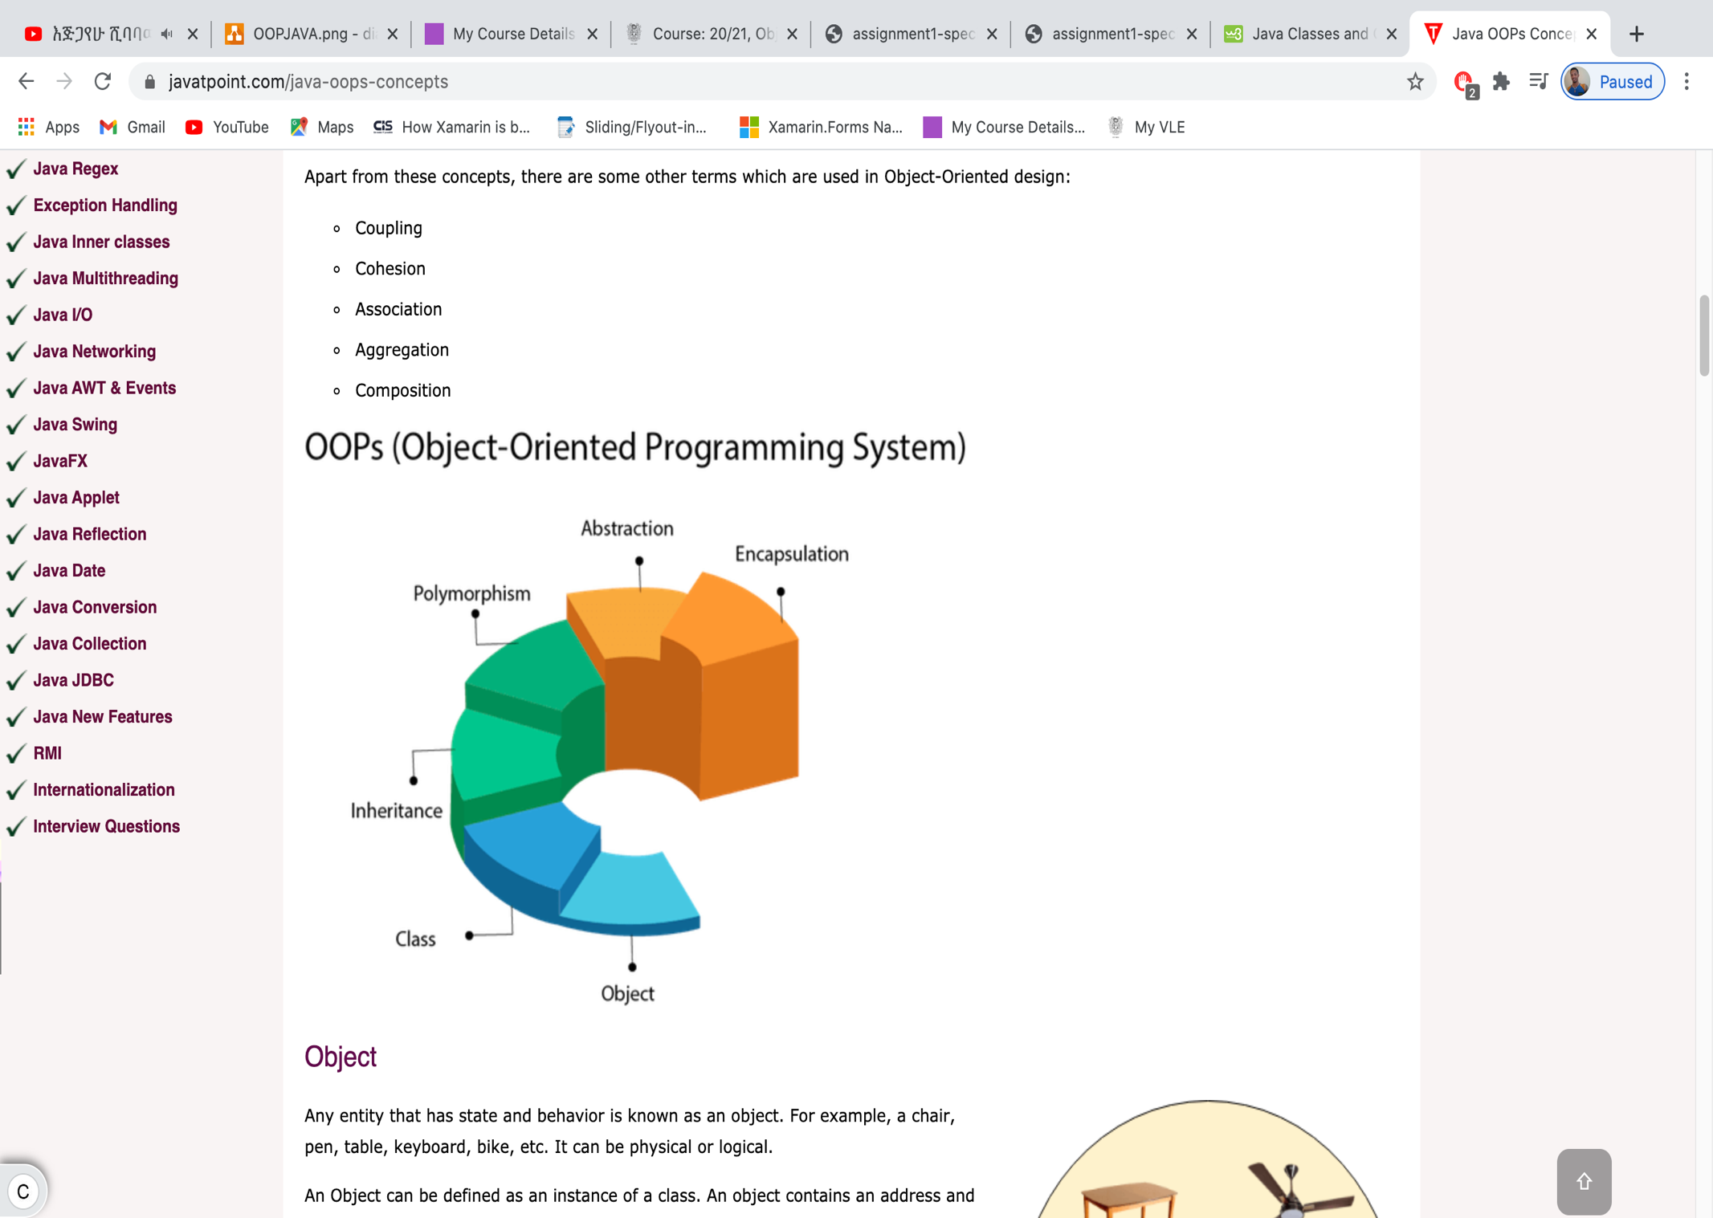

OOP programming techniques

## Inheritance

The mechanism that objects acquire all the properties and behaviours from the parent class is called inheritance. The main benefit of inheritance is that we can build new classes based on the existing classes. Whenever we inherit from the existing classes we can reuse the methods and fields of the parent class. This is very important to make to code organised and to save coding time.

For example:

class Employee{

float salary=40000;

}

class Programmer extends Employee{

int bonus=10000;

public static void main(String args[]){

Programmer p=new Programmer();

System.out.println("Programmer salary is:"+p.salary);

System.out.println("Bonus of Programmer is:"+p.bonus);

}

}

The outcome will be as follows

Programmer salary is:40000.0

Bonus of Programmer is:10000"

The above example demonstrate how a child class can inherit from parent class.

Which is the above example the programmer class inherited from the employee class.

## Polymorphism

The importance of polymorphism is the ability to display message in many forms. For example: there is a person called mike child who is a dad, a full time teacher and a course supervisor.

So this person can have different behaviour in different situation. This kind of one to many coding mechanism is called polymorphism.

There are two different way of using polymorphism.

This are called compile time polymorphism and runtime polymorphism.

### compile time polymorphism

compile time polymorphism(static polymorphism) can be coded by function overloading or operator overloading as it shows on the following image.

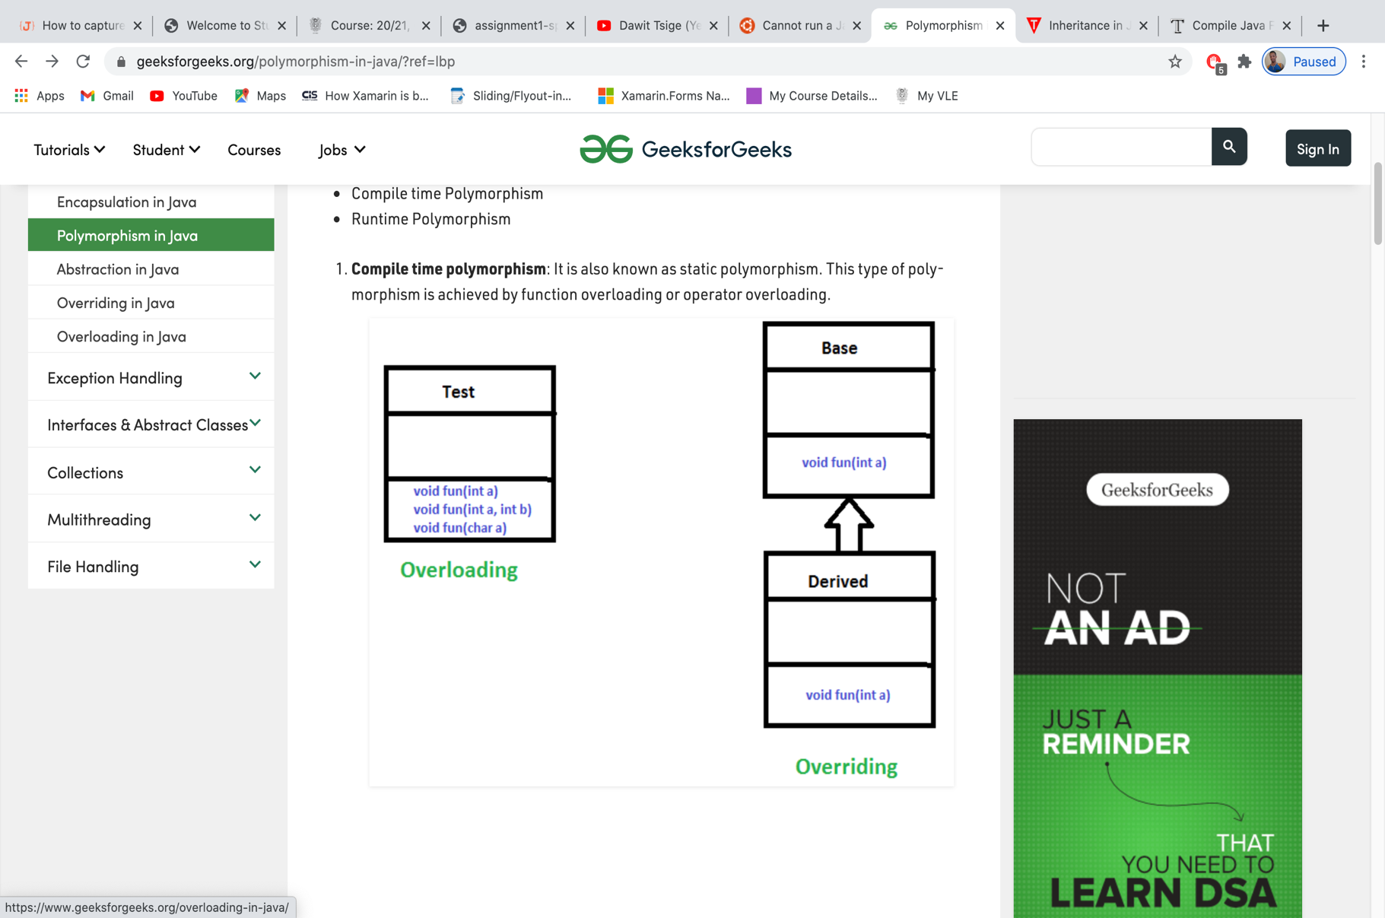

Polymorphism

#### Overloading polymorphism

Overloading allows different methods to have the same name, but different signatures where the signature can differ by the number of input parameters or type of input parameters or both. Overloading is related to compile-time (or static) polymorphism.

public class App {

// Overloaded App(). This App takes two int parameters

public int App(int x, int y)

{

return (x + y);

}

// Overloaded App(). This App takes three int parameters

public int App(int x, int y, int z)

{

return (x + y + z);

}

// Overloaded App(). This App takes two double parameters

public double App(double x, double y)

{

return (x + y);

}

// Driver code

public static void main(String args[])

{

App s = new App();

System.out.println(s.App(10, 20));

System.out.println(s.App(10, 20, 30));

System.out.println(s.App(10.5, 20.5));

}

}

The outcome looks as follows

30

60

31.0

#### Overriding polymorphism

In any object-oriented programming language, Overriding is a feature that allows a subclass or child class to provide a specific implementation of a method that is already provided by one of its super-classes or parent classes. When a method in a subclass has the same name, same parameters or signature, and same return type(or sub-type) as a method in its super-class, then the method in the subclass is said to override the method in the super-class.

// Base Class

class Parent {

void show()

{

System.out.println("mike as a dad()");

}

}

// Inherited class

class Child extends Parent {

// This method overrides show() of Parent

@Override

void show()

{

System.out.println("mike's children()");

}

}

class Main {

public static void main(String[] args)

{

Parent obj1 = new Parent();

obj1.show();

Parent obj2 = new Child();

obj2.show();

}

}

If the parent reference is referring to a child object it’s called run time polymorphism.

**The outcome looks as follows:**

mike as a dad()

mike's children()

### Runtime overriding polymorphism

Runtime overriding(dynamic method dispatch) is a process that a function called to overridden method is resolved at a runtime. This kind of polymorphism can be can be achieved by method overriding as it shows on the following code.

class Parent {

void Print()

{

System.out.println("This is parent class");

}

}

class subclass1 extends Parent {

void Print()

{

System.out.println("This is sub class 1");

}

}

class subclass2 extends Parent {

void Print()

{

System.out.println("This is sub class 2");

}

}

class TestPolymorphism3 {

public static void main(String[] args)

{

Parent a;

a = new subclass1();

a.Print();

a = new subclass2();

a.Print();

}

}

**In the above example the method is overridden.**

The outcome looks as follows:

This is sub class 1

This is sub class 2

## Abstraction

Abstraction is a concept of OOP programming that can help programmers to show the essential attributes and hide irrelevant information. In java abstraction can be achieved by interfaces and abstract classes. The following code shows the *Shape class* that have a color and size (McMillan, 2004).

abstract class Shape

{

String color;

// these are abstract methods

abstract double area();

public abstract String toString();

// abstract class can have constructor

public Shape(String color) {

System.out.println("Shape constructor called");

this.color = color;

}

// this is a concrete method

public String getColor() {

return color;

}

}

class Circle extends Shape

{

double radius;

public Circle(String color,double radius) {

super(color);

System.out.println("Circle constructor called");

this.radius = radius;

}

@Override

double area() {

return Math.PI * Math.pow(radius, 2);

}

@Override

public String toString() {

return "Circle color is " + super.color +

"and area is : " + area();

}

}

class Rectangle extends Shape{

double length;

double width;

public Rectangle(String color,double length,double width) {

// calling Shape constructor

super(color);

System.out.println("Rectangle constructor called");

this.length = length;

this.width = width;

}

@Override

double area() {

return length*width;

}

@Override

public String toString() {

return "Rectangle color is " + super.color +

"and area is : " + area();

}

}

public class App

{

public static void main(String[] args)

{

Shape s1 = new Circle("Red", 2.2);

Shape s2 = new Rectangle("Yellow", 2, 4);

System.out.println(s1.toString());

System.out.println(s2.toString());

}

}

**The outcome looks as follows**

Shape constructor called

Circle constructor called

Shape constructor called

Rectangle constructor called

Circle color is Redand area is : 15.205308443374602

Rectangle color is Yellowand area is : 8.0

## Encapsulation

Encapsulation is a technic of wrapping the data(variables) and code acting on the data(methods) together as a single unit. It’s one of the four key concepts in OOP. In the encapsulation technic, the variables of the class will be hidden from another classes and it can be accessed only through the methods as it shows on the following code example (tutorialsPoint, 2018).

public class Encapsulate {

private String vehicleName;

private String vehicleRoll;

private int vehicleAge;

// get method for age to access

// private variable vehicleAge

public int getAge()

{

return vehicleAge;

}

// get method for name to access

// private variable vehicleName

public String getName()

{

return vehicleName;

}

// get method for roll to access

// private variable vehicleRoll

public String getRoll()

{

return vehicleRoll;

}

// set method for age to access

// private variable vehicleage

public void setAge( int newAge)

{

vehicleAge = newAge;

}

// set method for name to access

// private variable vehicleName

public void setName(String newName)

{

vehicleName = newName;

}

// set method for roll to access

// private variable vehicleRoll

public void setRoll( String newRoll)

{

vehicleRoll = newRoll;

}

}

public class TestEncapsulation

{

public static void main (String[] args)

{

Encapsulate obj = new Encapsulate();

// setting values of the variables

obj.setName("BMW");

obj.setAge(19);

obj.setRoll("for transportation");

// Displaying values of the variables

System.out.println("vehicle name: " + obj.getName());

System.out.println("vehicle age: " + obj.getAge());

System.out.println("vehicle roll: " + obj.getRoll());

// Direct access of vehicleRoll is not possible

// due to encapsulation

// System.out.println("vehicle's roll: " + obj.vehicleName);

}

}

The output shows as follows

vehicle name: BMW

vehicle age: 19

vehicle roll: for transportation

# The given scenario

In order to draw the clear image of how the given scenario I am going to use UML diagram.

## What is UML diagram

The unified modelling language is very important tool to address what is needed in the system. UML is the key to organize the design in a way that analysts, clients, programmers, and others involved in the system development can understand and agree on (Schmuller, 2004).

There for I am going to use the UML class diagram to address the requirements of the system.

### Class diagram

A class diagram is a category or group of things that have the same attributes and the same behaviours.

There for I am going to use the UML class diagram to address the requirements of the system.



UML Diagram of the system

# Uploading images using buttons or similar mechanism.

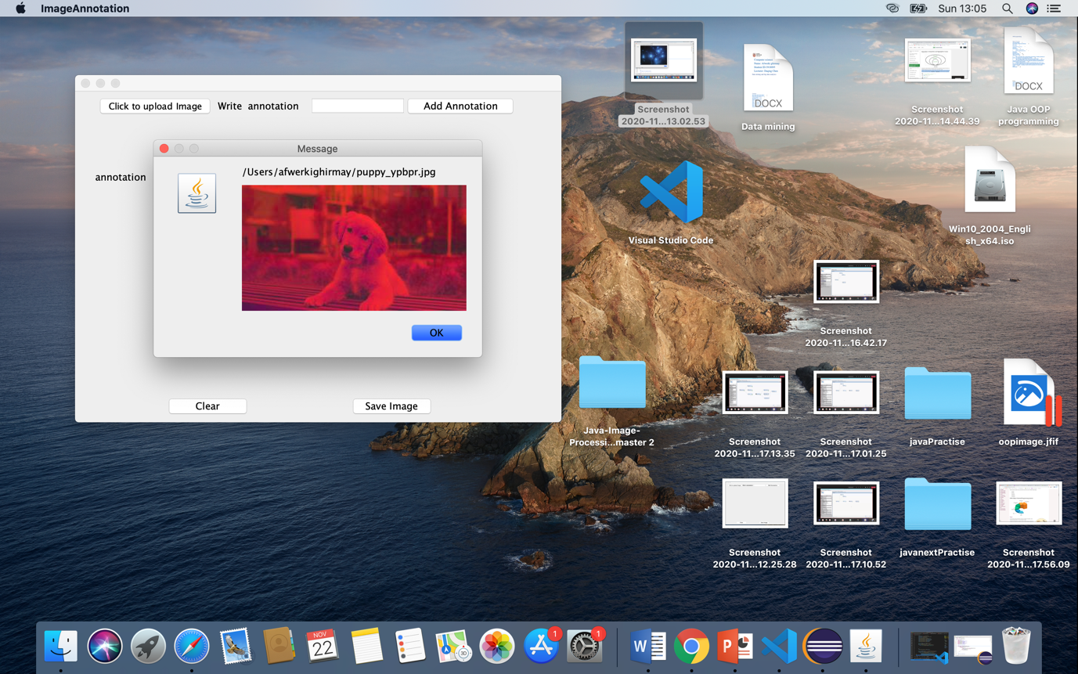

Image uploading

public class ImageAnnotation {

Creating class

JLabel label;

private JFrame frame;

Making all components accessible into the class

private JTextField txtAnnotation;

private JButton btnUpload;

private JButton btnClear;

private JButton btnAddAnnotation;

private JButton btnSave;

private JLabel lblanotation;

This is a main method to run the class

public static void main(String[] args) {

EventQueue.invokeLater(new Runnable() {

public void run() {

try {

ImageAnnotation window = new ImageAnnotation();

window.frame.setVisible(true);

} catch (Exception e) {

e.printStackTrace();

}

}

});

Creating the app

}

Initializing the contents of the frame

public ImageAnnotation() {

initialize();

Set the size of the frame

}

Default method for closing

private void initialize() {

Set Button size

frame = new JFrame();

frame.setBounds(100, 100, 650, 464);

Set Text font

frame.setDefaultCloseOperation(JFrame.EXIT_ON_CLOSE);

actionListener to get into desktop

JButton btnUpload = new JButton("Click to upload Image");

btnUpload.setBounds(27, 6, 160, 29);

btnUpload.setFont(new Font("Lucida Grande", Font.PLAIN, 12));

btnUpload.addActionListener(ev -> {

JFileChooser fc = new JFileChooser(System.getProperty("user.home"));

fc.addChoosableFileFilter(new FileNameExtensionFilter("Image files",

new String[] {"png","jpg","jpeg","gif"}));

if(fc.showOpenDialog(null)== JFileChooser.APPROVE_OPTION) {

try {

Image image = ImageIO.read(fc.getSelectedFile());

JfileChooser to choose only Image

if(image != null) {

JPanel panel = new JPanel(new BorderLayout(10, 10));

panel.add(new JLabel(fc.getSelectedFile().toString()),

BorderLayout.NORTH);

Reading the selected file

panel.add(new JLabel(new ImageIcon(image)));

JOptionPane.showMessageDialog(frame, panel);

}

}catch (Exception ex) {

ex.printStackTrace();

}

}

});

# UI resizing to fit the image

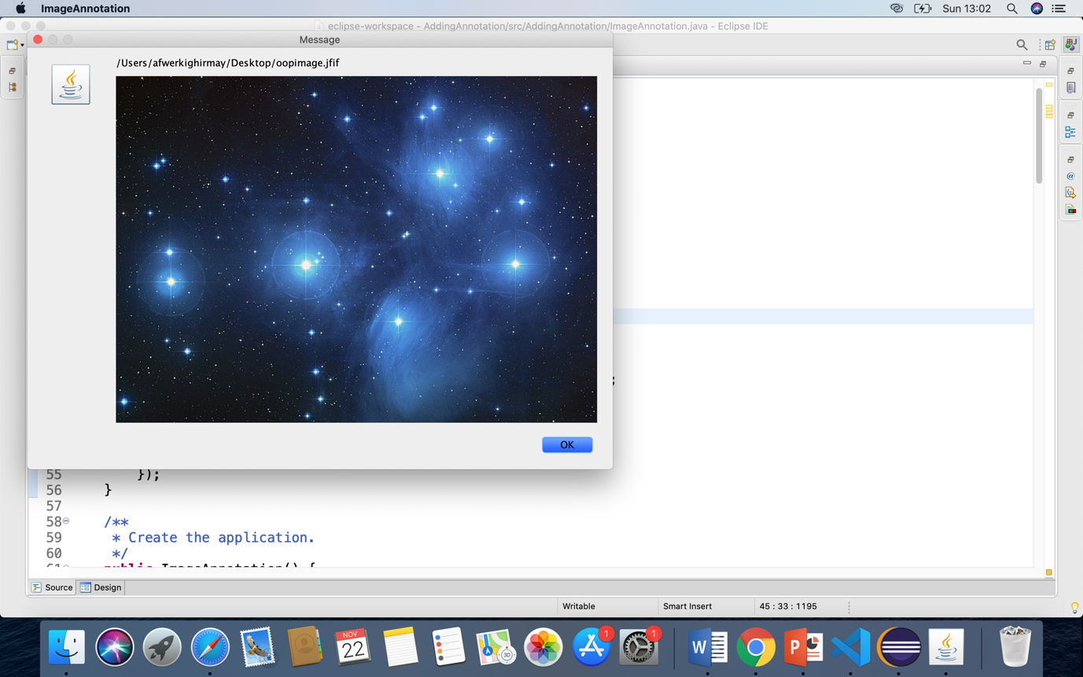

UI resizing to fit the image



UI resizing to fit another image

# Adding or removing any number of annotation

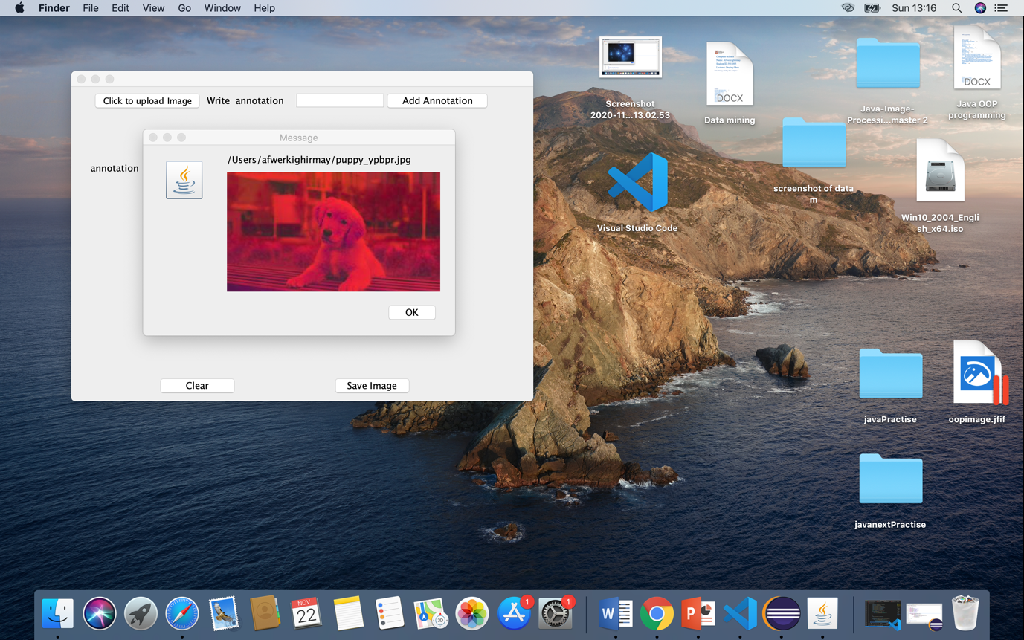

Adding and removing annotation

JLabel lblAnnotation = new JLabel(" Write annotation");

lblAnnotation.setBounds(187, 8, 149, 23);

# Saving the annotated image



The annotated image saving

JButton btnSave = new JButton("Save Image");

btnSave.setBounds(365, 407, 117, 29);

btnSave.addActionListener(new ActionListener() {

public void actionPerformed(ActionEvent e) {

try

{

JFileChooser chooseDirec = new JFileChooser();

chooseDirec.setFileSelectionMode(JFileChooser.FILES_ONLY);

//chooseDirec.showSaveDialog(this);

File file = chooseDirec.getSelectedFile();

file = new File(file+".png");

BufferedWriter bufferedWriter = new BufferedWriter(new FileWriter(file));

bufferedWriter.close();

}

catch (IOException exception)

{

System.err.println("Error saving to new file.");

}

}

});

# Conclusion

Overall the code is not as good as it suppose to be. The reason is because with the current situation I am not unable to focus. However this project a homework for me. For example. Even though I uploaded the image into the system, I couldn’t put the text(annotation) on it.

However I am going to make sure I get everything write during the Christmas break.

# Bibliography

Help, S. T. (2018, Dcember 21). *Java Composition – What Is Composition (Has-A) In Java*. Retrieved from Software Testing Help: https://www.softwaretestinghelp.com/composition-in-java/

Javatpoint. (2016, January 27). *Javatpoint Logo*. Retrieved from Java OOPs Concepts: https://www.javatpoint.com/java-oops-concepts

McMillan, J. W. (2004). *java programming: Advanced Topics.* CANADA: THOMSON COURSE TECHNOLOGY.

Schmuller, J. (2004). *Sams Tech Yourself UML in 24 Hours.* USA: Sams Publishing .

tutorialsPoint. (2018, January 16). *Java - Encapsulation*. Retrieved from tutorialsPoint: https://www.tutorialspoint.com/java/java_encapsulation.htm